# 2019 PartyMix mapping for VDJ with 2x shifts and ColorFx - v0.8.0 - DJ Estrela

TO DOWNLOAD: you can ONLY download if you register and then verify your email in the DJTT site!

Links:

* Download: <https://maps.djtechtools.com/mappings/9764>
* Demo video: <https://youtu.be/W6yuVs0ah2k>
* Installation video (starts at 7:30): <https://youtu.be/W6yuVs0ah2k>
* Documentation: <https://github.com/pestrela/music/tree/master/traktor/mapping_party_mix>

FEATURE LIST:

* 2x shift layers
* Filter knob
* 10x colorFX
* Loop adjust
* Cue delete
* 7x FX and FX control
* Censor
* Zoom and Tempo range
* 4x Rolls
* Jog Search

Summary:

* This is a 2019 mapping for the numark PartyMix for VirtualDJ 2020. Major feature are 2x shifts layers that adds more functions than the available buttons, and a dedicated Filter knob.
* Other features are 10x ColorFX, Cues delete, Loop adjust, 4x Loop roll mode, and 7x FX control. Also available is Zoom, jog search, Tempo range

Installation:

* To install this mapping, please decompress the inner zip and copy the contents to your documents/VDJ folder
* See the step by step demo: <https://youtu.be/W6yuVs0ah2k>
* Official VDJ installation instructions: <https://www.virtualdj.com/manuals/hardware/numark/partymix/>

Features demo: <https://youtu.be/W6yuVs0ah2k>

* 0:07 Quick overview (2x shifts, ColorFX, …)
* 1:30 Gain / EQ / Filter / FX control knobs
* 2:16 extra shift functions on transport
* 3:10 HotCue delete, Custom Loops, Censor
* 5:22 FX access and FX modulation
* 6:00 Direct shortcut to 10x ColorFX: Filter / Eccho / Noise / Flanger / …

Installation step by step: <https://youtu.be/W6yuVs0ah2k>

* 7:30 How to download the mapping
* 8:10 You need to register and verify your email on the DJTT site!
* 8:50 Extract the inner zip file into your documents folder. Overwrite existing files (make a backup first)
* 10:00 Enable the mapping in the settings / controllers

Overview:

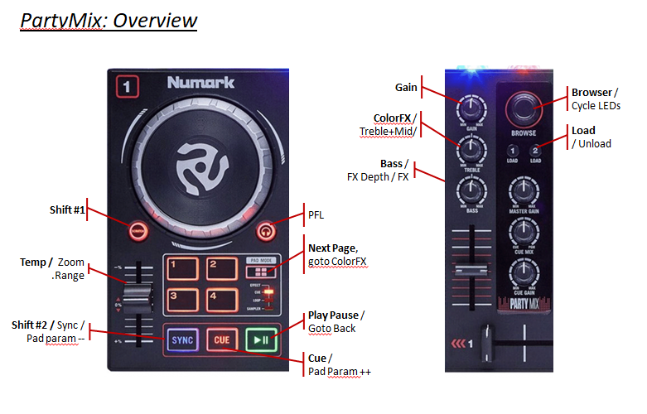

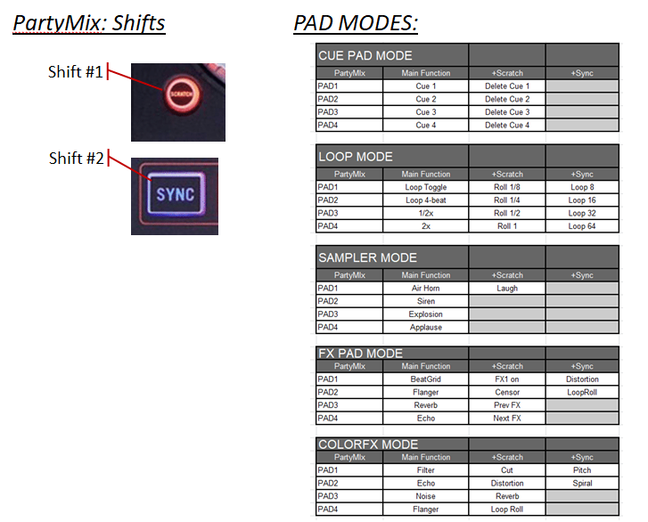

Detailed reference:

|  |  |  |  |
| --- | --- | --- | --- |
|  |  |  |  |
| PartyMIx | Main Function | +Scratch | +Sync |
| SCRATCH | ***Shift #1*** |  |  |
| SYNC | ***Shift #2*** |  |  |
|  |  |  |  |
| GAIN | **Gain** |  |  |
| TREBLE | **Filter** | Treble+Mid | Treble+Mid |
| BASS | **Bass** | FX parameter #1 | FX paarmeter #2 |
|  |  |  |  |
| PAD MODE | **Select 4x Pages** | Goto ColorFX | Next PadPage |
| PAD 1..4 | **Pad 1..4** | Pad 5..8 | Shift + Pad 1..4 |
|  |  |  |  |
| SYNC | **Sync** | Pad Param ++ |  |
| CUE | **Cue** | Pad Param -- |  |
| PLAY | **Play/Pause** | Go to Beginning |  |
| PITCH | **Tempo** | Zoom | Tempo Range |
| JOG | **Bend** | Scratch | Search |
|  |  |  |  |
| BROWSE | **Browse** | Cycle LEDs |  |
| LOAD | **Load** | UnLoad |  |